Alt+ctrl+t

Top: these all are individual processes and the terminal keeps on updating. Some of the processes are running…all are in diff. states

#The top command in Unix/Linux is a system monitoring utility that provides a dynamic, real-time view of the running system. It displays a list of processes or threads currently being managed by the kernel, along with various metrics related to system resource usage.

**Key Features of top:**

* **Process Information**: Lists processes with their PID (Process ID), user, priority, and more.
* **Resource Usage**: Shows CPU and memory usage per process.
* **System Summary**: Displays system-wide metrics like overall CPU usage, memory usage, swap space, load averages, etc.
* **Interactive Commands**: Allows you to interact with the display (e.g., sorting by different columns, killing processes, etc.).

**Common Columns in top:**

* **PID**: Process ID.
* **USER**: User who owns the process.
* **PR**: Priority of the process.
* **%CPU**: CPU usage percentage.
* **%MEM**: Memory usage percentage.
* **TIME+**: Total CPU time the process has used since it started.
* **COMMAND**: Command name or path that started the process.

**Basic Usage:**

* Simply type top in the terminal to start the command.
* Press q to quit.

**Interactive Commands:**

* **M**: Sort processes by memory usage.
* **P**: Sort processes by CPU usage.
* **k**: Kill a process (requires PID input).
* **h**: Display help.

It's a useful command for system administrators to monitor and manage system performance.

* Ctrl + c , clear
* Ctrl + c to come out of execution of top commnd
* Sabkuch 1041 me krna ha
* System me jitne ressources uska detail lena ha
* how to chk the details of cpu ..command in linux : lscpu
* mips : Million instructions per second
* As the number of instructions sent Saved increases per second, the frequency of transfer also increases, which results in the increase of power consumption And finally, in the consumption of energy. And thus a lot of energy is utilised in sending even one message
* p=v^2cf, e=p*t more bills advance OS research
* lscpu
* cat /proc/cpuinfo
* how to chk memory : free -h
* chk memory status : vmstat
* sudo dmidecode : The dmidecode command fetches the system's hardware information, including detailed memory details such as installed RAM, memory slots, etc.
* sudo stands for **"SuperUser DO"**. It allows a permitted user to execute a command as the superuser (root) or another user, as specified by the security policy configured in /etc/sudoers.
* password : 834010
* vm : admin
* kisi bhi process ka resource status dekh krke batao command req.
* how can we access the particular field of top table
* how to access a particukar row of a process
* regex is imp
* vi : to view a file: vi filename

Commands

1. If you want to see all the processes run by you, you can use the ps command with options x like this: ps -x

**My notes:**

#To check the details of the CPU in a Linux system, you can use several commands. Here are some of the most common ones:

**1. lscpu**

* This command provides an overview of the CPU architecture, including the number of CPUs, cores, threads, and more.

lscpu

**2. cat /proc/cpuinfo**

* This command displays detailed information about the CPU(s), including model name, clock speed, cache size, etc.

cat /proc/cpuinfo

* You can also filter this output to get specific information, like the model name:

cat /proc/cpuinfo | grep 'model name'

**3. nproc**

* This command simply outputs the number of processing units available.

nproc

**4. dmidecode -t processor**

* This command provides detailed information about the processor, including manufacturer, version, and other details. You might need root privileges to run this command.

sudo dmidecode -t processor

**5. top or htop**

* These commands are used for monitoring system processes but also show CPU usage and other details in real-time. htop is more user-friendly but might need to be installed.

top

htop

**6. inxi -C**

* If inxi is installed, this command provides a concise summary of the CPU information.

inxi -C

These commands will give you a comprehensive overview of your CPU's details in a Linux environment.

------------------------------------------------------------------------------------------------------------------

# To see the resource status of a process in Linux, you can use several commands. Here are some of the most common ones:

**1. top Command**

* The top command provides a real-time, dynamic view of system processes, showing CPU, memory usage, and other details.

top

* Press Shift + p to sort processes by CPU usage.
* Press Shift + m to sort by memory usage.
* Press Shift + n to sort by process ID.

**2. htop Command**

* htop is an interactive process viewer that is more user-friendly than top. It shows the same information but in a more accessible format.

htop

* You can scroll through the list of processes and see detailed information about each one, including CPU and memory usage.

**3. ps Command**

* The ps command displays information about active processes. You can use various options to filter and sort the output.

ps aux

* ps aux shows all running processes with their resource usage.
* To see the resource usage of a specific process

#Note:

1. Unix is foundation of linux

Ubuntu is linux disturibution

Mac Os is also unix based,,,,unix ko dekhke linux bana tha  
unix is older than linux And as a propiertory software while the Linux is free ie. Its is a freeware

RAM should be more to run linux properly and fast

1. CLI & GUI

There are two types of interfaces :

command line interface CLI

graphical user interface GUI

* Windows focus on gui more than the cli, although it can also use cli
* Line in Linux, the programmers mainly use the cli along with a bit of Gui..ie. terminal me hi gui add kia gya ha
* Ls means to list the contents of the directory
* Windows has drives like c drive etc..but linux has a tree structure
* / is the root node
* Cd / -> takes to root folder
* Ls show root fldr ke children
* Fldrs in linux root fldr that u will see in all Distributions of Linux:  
  etc bin usr tmp dev
* $ in VM linux commands Means That I am a regular user
* To see the absolute path of any folder or file write :Pwd
* Touch command is used to create a blank file: touch 1.txt
* Mv is move command Use to move a file from one folder to another
  + mv touch file.txt fldr_name
  + cp touch file.txt fldr_name – Used to copy a file to another folder

**Difference Between Absolute and Relative Path in Linux**

**1. Absolute Path**

* **Definition**: An absolute path specifies the full path to a file or directory from the root directory (/). It starts from the root directory and provides the complete location of the file or directory in the filesystem hierarchy.
* **Characteristics**:
  + Always begins with a / (the root directory).
  + Unambiguous and always points to the same location, regardless of the current working directory.
* **Example**:
  + /home/user/documents/report.txt
  + /var/www/html/index.html
* **Use Case**:
  + When you need to specify a path from any location, ensuring that the correct file or directory is accessed.

**2. Relative Path**

* **Definition**: A relative path specifies the location of a file or directory relative to the current working directory. It doesn't start from the root but from the directory you are currently in.
* **Characteristics**:
  + Does not begin with /.
  + Dependent on the current working directory.
  + Can use . (current directory) and .. (parent directory) to navigate.
* **Example**:
  + documents/report.txt (if you are in /home/user)
  + ../pictures/photo.jpg (refers to a file in the parent directory's pictures folder)
* **Use Case**:
  + When working within a known directory structure, where relative paths are more convenient and shorter to type.

**How to Get Both Absolute and Relative Paths in Linux**

**Getting the Absolute Path**

* **Method 1: Using pwd (Print Working Directory)**
  + The pwd command prints the absolute path of the current working directory.

**Example**:

pwd

* + Output might be something like /home/user/documents, which is the absolute path of the current directory.
* **Method 2: Using realpath**
  + The realpath command returns the absolute path of a file or directory.

**Example**: realpath report.txt

23:32 harry: How to move files from folder to another using full path

#note:  
the two main types of users in Linux:

**1. Regular User**

* **Home Directory**: Each regular user has a personal directory where they store their files and personal settings. This directory is typically located in /home/username, where username is the name of the user. For example, if your username is shakti, your home directory would be /home/shakti.
* **Permissions**: Regular users have limited permissions. They can access and modify files within their own home directory but generally cannot modify system files or settings that affect other users or the entire system.

**2. Root User**

* **Full Access**: The root user is a special user in Linux with the highest level of access to the system. This user has full control over the system and can perform any action, such as installing software, modifying system settings, and accessing any files on the system, regardless of the permissions set for other users.
* **Critical Role**: The root user is often used for administrative tasks and is the only user who can make significant changes to the system. However, because of the power of the root user, it is also a role that should be used carefully to avoid accidentally causing system-wide issues.

**Additional Notes:**

* **U1, U2, U3**: These seem to represent different regular users on the system. Each of these users would have their own home directory and their own set of permissions.

**Summary:**

* **Regular Users** have limited permissions and their own home directory.
* **Root User** has full access to the system and can perform any action on the system.also called SuperUser and is the admin.

Understanding the difference between these types of users is crucial as it helps in managing permissions and system security in Linux.

There is also a 3rd user that is not used mostly ..accled service user

* Sudo command is used to take up the permissions which were previouslydenied for some specific commands
* sudo su : : This stands for "substitute user" and allows you to switch to another user account. By default, it switches to the root user if no other user is specified.
* Tree structure in Linux of folders and files:
* 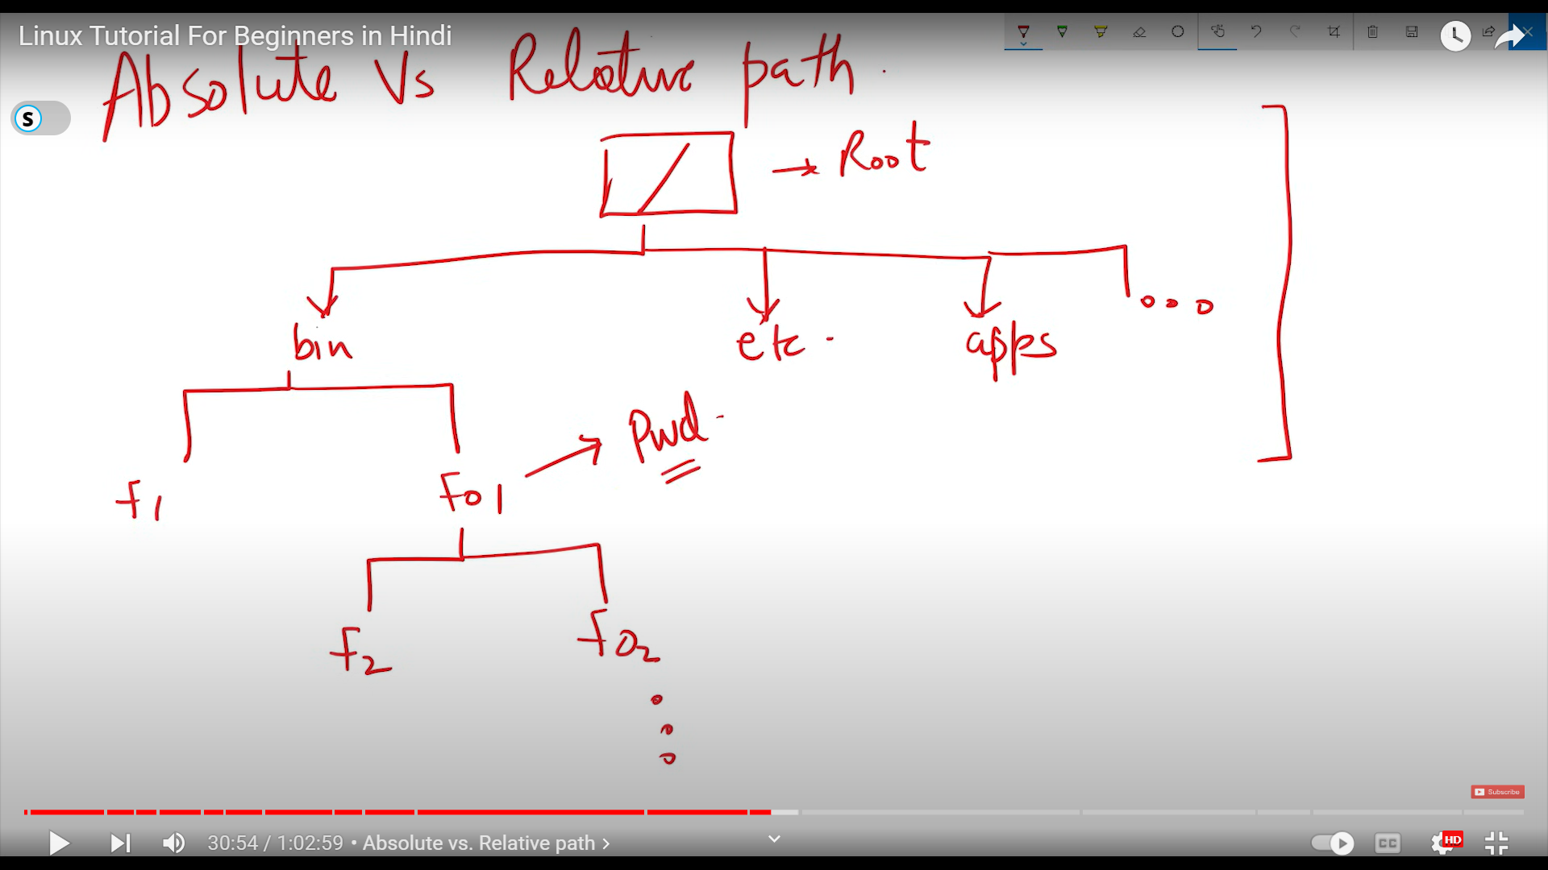
* $ sign after the command means that I’m a ‘regular user’
* To switch mode to super user we can start writing our command with Sudo
* But if we want to write all the next commands entirely as a super user, we can write sudo su But this is not recommended
* Apt Can be used to instal softwares in the system: apt (Advanced Package Tool) is a command-line tool used in Debian-based Linux distributions (like Ubuntu) for handling packages. It simplifies the process of managing software on your system, including installing, updating, and removing packages.
* -> sudo apt update